AT: Heidegger
AT: Heidegger/Eco-Managerialism 1
Aff: Heidegger Kills Agency 2
(Aff) Heidegger =/= Anti-Technological 3
Heidegger→Nazism 5
2AC - Perm 6
1AR EXT – Perm 7
Violence Turn 8
Survival Key to Ontology 9
Perm – Visioning (1/2) 10
Perm: Visioning (2/2) 11
Humanism Good 12
Heidegger→Nazism 13

Aff: Heidegger Kills Agency
Heidegger’s essentialism gives way to a deterministic approach to human agency and precludes pragmatic political solutions to the problems of technology.
David Edward Tabachnick, Nipissing University, 2008, “Heidegger’s Essentialist Responses to the Challenge of Technology ”

His harshest criticism of essentialism is saved for Martin Heidegger, whom he sees as its progenitor, pointing to his enframing (Gestell) and standing-reserve (Bestand) arguments as particularly disempowering, promoting inaction or a “politically dehabilitating substantivism” ~Thomson, 2000: 435! in the face of the many inequities and challenges presented by contemporary technology.1 Inspired by the work of Heidegger’s student Herbert Marcuse, Feenberg endorses and describes a constructivism that he understands will allow for positive human intervention into the development and design of technology, directing it toward a free and equal society. As with Feenberg’s own inter pretation of Marcuse, the application of constructivism “would require not merely a political and social revolution but the end of the Gestell, Heidegger’s technological age, since it would replace the ‘standing-reserve’ with a living world once again” ~2005: 137!. In other words, the achievement of the political and cultural goals of constructivism is dependent upon a preliminary reproach of essentialism.
(Aff) Heidegger =/= Anti-Technological
Heidegger’s writings are misappropriated by radical ecologists – his philosophy is not anti-technological, but is easily mistaken for Luddite reactionism

Charles Dreyfus, Professor of Philosophy at UC Berkeley; 1993; “Heidegger on the connection between nihilism, art, technology, and politics”; “The Cambridge Companion to Heidegger”, p 303

But Heidegger does not oppose technology. In “The Question Concerning Technology” he hopes to reveal the essence of technology in a way that “in no way confines us to a stultified compulsion to push on blindly with technology or, what comes to the same thing, to rebel helplessly against it.” Instead, he promises that “when we once open ourselves expressly to the essence of technology, we find ourselves unexpectedly taken into a freeing claim” (QCT 25-6; VA 33).
We will need to explain opening, essence and freeing before we can understand Heidegger here. But already Heidegger’s project should alert us to the fact that he is not announcing one more reactionary rebellion against technology, although many take him to be doing just that. Nor is he doing what progressive thinkers would like to do: proposing a way to get technology under control that that it can serve our rationally chosen ends. The difficulty in locating just where Heidegger stands on technology is no accident. Heidegger has not always been clear about what distinguishes his approach from a romantic reaction to the domination of nature, and when he does finally arrive at a clear formulation of his original view, it is so strange that in order to understand it we are tempted to translate it into conventional platitudes. Thus, Heidegger’s ontological concerns are mistakenly assimilated to ecologically minded worries about the devastation of nature.

Inaction → Genocide

Moral skepticism at the cost of action makes us complicit with genocide
Violet B. Ketels, Associate professor of English @ Temple University, Annals of the American Academy of Political and Social Science, Vol. 548, The Holocaust: Remembering for the Future, 11-1996, pp. 45-69, "Havel to the Castle!" The Power of the Word, [JSTOR].

Even though, as Americans, we have not experienced "by fire, hunger and the sword"'9 the terrible disas- ters in war overtaking other human beings on their home ground, we know the consequences of human hospitality to evil. We know about human perfidy: the chasm that sepa- rates proclaiming virtue from acting decently. Even those of us trained to linguistic skepticism and the relativity of moral judgment can grasp the verity in the stark warning, "If some- thing exists in one place, it will exist everywhere."20 That the dreadful something warned against continues to exist anywhere should fill us with an inextinguishable yearning to do something. Our impotence to action against the brutality of mass slaugh- ter shames us. We have the historical record to ransack for precedent and corollar- ies-letters, documents, testaments, books-written words that would even "preserve their validity in the eyes of a man threatened with instant death."21 The truths gleanable from the record of totalitarian barbarism cited in them may be common knowl- edge; they are by no means commonly acknowledged.22 They appear in print upon many a page; they have not yet-still not yet-sufficiently pene- trated human consciousness. Herein lies the supreme lesson for intellectuals, those who have the pro- jective power to grasp what is not yet evident to the general human con- sciousness: it is possible to bring down totalitarian regimes either by violence or by a gradual transforma- tion of human consciousness; it is not possible to bring them down "if we ignore them, make excuses for them, yield to them or accept their way of playing the game"23 in order to avoid violence. The history of the gentle revolu- tions of Poland, Hungary, and Czechoslovakia suggests that those revolutions would not have happened at all, and certainly not bloodlessly, without the moral engagement and political activism of intellectuals in those besieged cultures. Hundreds of thousands of stu- dents, workers, and peasants joined in the final efforts to defeat the totali- tarian regimes that collapsed in 1989. Still, it was the intellectuals, during decades when they repeatedly risked careers, freedom, and their very lives, often in dangerous solitary challenges to power, who formed the unifying consensus, developed the liberating philosophy, wrote the ral- lying cries, framed the politics, mobi- lized the will and energies of dispa- rate groups, and literally took to the streets to lead nonviolent protests that became revolutions. The most profound insights into this process that gradually pene- trated social consciousness suffi- ciently to make revolution possible can be read in the role Vaclav Havel played before and during Czechoslo- vakia's Velvet Revolution. As George Steiner reflects, while "the mystery of creative and analytic genius ... is given to the very few," others can be "woken to its presence and exposed to its demands."24 Havel possesses that rare creative and analytic genius. We see it in the spaciousness of his moral vision for the future, distilled from the crucible of personal suffering and observation; in his poet's ability to translate both experience and vision into language that comes as close as possible to truth and survives trans- lation across cultures; in the compel- ling force of his personal heroism. 24. Steiner, Proofs, pp. 48-49. Characteristically, Havel raises lo- cal experience to universal relevance. "If today's planetary civilization has any hope of survival," he begins, "that hope lies chiefly in what we understand as the human spirit." He continues: If we don't wish to destroy ourselves in national, religious or political discord; if we don't wish to find our world with twice its current population, half of it dying of hunger; if we don't wish to kill ourselves with ballistic missiles armed with atomic warheads or eliminate ourselves with bacteria specially cultivated for the pur- pose; if we don't wish to see some people go desperately hungry while others throw tons of wheat into the ocean; if we don't wish to suffocate in the global greenhouse we are heating up for ourselves or to be burned by radiation leaking through holes we have made in the ozone; if we don't wish to exhaust the nonrenewable, mineral resources of this planet, without which we cannot survive; if, in short, we don't wish any of this to happen, then we must-as humanity, as people, as con- scious beings with spirit, mind and a sense of responsibility-somehow come to our senses.25 Somehow we must come together in "a kind of general mobilization of hu- man consciousness, of the human mind and spirit, human responsibil- ity, human reason."26

Heidegger→Nazism
The Heideggerian search for truth concludes in the affirmation of fascism – his complicity with the Nazi order was not an anomaly in his beliefs, but an actual danger of delineating ontological ‘truth’
Slavoj Zizek, former Senior Researcher at the Institute for Social Sciences in Ljubljana, 1999; The Ticklish Subject, p. 13-15
When, in my youth, I was bombarded by the official Communist philosophers' stories of Heidegger's Nazi engagement, they left me rather cold; I was definitely more on the side of the Yugoslav Heideggarians. All of a sudden, however, I became aware of how these Yugoslav Heideggarians were doing exactly the sauce thing with respect to the Yugoslav ideology of self-management as Heidegger himself did with respect to Nazism: in ex-Yugoslavia, Heideggerians entertained the same ambiguously assertive relationship towards Socialist self- management, the official ideology of the Communist regime - in their eyes, the essence of sell-management was the very essence of modern man, which is why the philosophical notion of self-managemrnt suits the ontological essence of our epoch, while the standard political ideology of the regime misses this 'inner greatness' of self-management ... Heideggerians are thus eternally in search of a positive, ontic political system that would come closest to the epochal ontological truth, a strategy which inevitably leads to error (which, of course, is always acknowledged only retroactively, post factum, after the disastrous outcome of one's engagement). As Heidegger himself put it, those who carne closest to the Ontological Truth are condemned to err at the ontic level ... err about what? Precisely about the line of separation between ontic and ontological. The paradox not to be underestimated is that the very philosopher who focused his interest on the enigma of ontological difference - who warned again and again against the metaphysical mistake of conferring ontological dignity on some ontic content (God as the highest Entity, for example) - fell into the trap of conferring on Nazism the ontological dignity of suiting the essence of modern man. The standard defence of Heidegger against the reproach of his Nazi past consists of two points: not only was his Nazi engagement a simple personal error (a ‘stupidity [Dummheit]', as Heidegger himself put it) in no way inherently related to his philosophical project; the main counter-argument is that it is Heidegger's own philosophy that enables us to discern the true epochal roots of modern totalitarianism. However, what remains unthought here is the hidden complicity between the ontological indifference towards concrete social systems (capitalism, Fascism. Communism), in so far as they all belong to the same horizon of modern technology, and the secret privileging of a concrete sociopolitical model (Nazism with Heidegger, Communism with some 'Heideggerian Marxists') as closer to the ontological truth of our epoch.Here one should avoid the trap that caught Heidegger's defenders, who dismissed Heidegger’s Nazi engagement as simple an anomaly, a fall into the ontic level, in blatant contradiction to his thought, which teaches us not to confuse ontological horizon with ontic choices (as we have already seen, Heidegger is at his strongest when he demonstrates how, on a deeper structural level, ecological, conservative, and so on, oppositions to the modern universe of technology are already embedded in the horizon of what they purport to reject: the ecological critique of the technological exploitation of nature ultimately leads to a more 'environmentally sound' technology. etc.). Heidegger did not engage in the Nazi political project 'in spite of' his ontological philosophical approach, but because of it; this engagement was not 'beneath' his philosophical level - on the contrary if one is to understand Heidegger, the key point is to grasp the complicity (in Hegelese: 'speculative identity') between the elevation above ontic concerns and the passionate 'ontic' Nazi political engagement. One can now see the ideological trap that caught Heidegger: when he criticizes Nazi racism on behalf of the true 'inner greatness' of the Nazi movement, he repeats the elementary ideological gesture of maintaining an inner distance towards the ideological text - of claiming that there is something more beneath it, a non-ideological kernel: ideology exerts its hold over us by means of this very insistence that the Cause we adhere to is not 'merely' ideological. So where is the trap? When the disappointed Heidegger turns away from active engagement in the Nazi movement, he does so because the Nazi movement did not maintain the level of its 'inner greatness', but legitimized itself with inadequate (racial) ideology. In other words, what he expected from it was that it should legitimize itself through direct awareness of its 'inner greatness'. And the problemlies in this very expectation that a political movement that will directly refer to its historico-ontological foundation is possible. This expectation, however, is in itself profoundly metaphysical, in so far as it fails to recognize that the gap separating the direct ideological legitimization of a movement from its 'inner greatness' (its historico-ontological essence) is constitutive, a positive condition of its 'functioning'. To use the terms of the later Heidegger, ontological insight necessarily entails ontic blindness and error, and vice versa - that is to say, in order to be 'effective' at the ontic level, one must disregard the ontological horizon of one's activity. (In this sense, Heidegger emphasizes that 'science doesn't think' and that, far from being its limitation, this inability is the very motor of scientific progress.) In other words, what Heidegger seems unable to endorse is a concrete political engagement that would accept its necessary, constitutive blindness - as if the moment we acknowledge the gap separating the awareness of the ontological horizon from ontic engage*ment, any ontic engagement is depreciated, loses its authentic dignity.
2AC - Perm
Only the permutation can solve the necessary deconstruction of the institution and reconstruction of a radical politics through democratic struggle.
Gregory Fried, Professor of Philosophy @ University of Suffolk, 2003, Heidegger’s Polemos, Page 248-250, [Dartmouth Library, Static Text].
But we cannot just relax. To the extent that Enlightenment ideals of freedom and right have found expression in liberal institutions and civil society it seems clear that these both, as well as the principles that underlie them, are now under stress.’ Nor can institutions and civil society be shored up simply by insistence on the foundations (whether in the mode of Rorty’s ironic traditionalism or of an absolutist faith in the “original intent” of the “Founding Fathers”), as if the principles of liberal, democratic societies and governments were given by divine revelation and therefore not subject to question. In a very broad sense, postmodernists are right: we must remain free to inquire into (to “deconstruct”) our founding principles; the principles will not simply stay put. If polemos means both an ongoing need for and a persistent openness to interpretation and questioning, then freedom demands polemos—and the polemos demands freedom. But of course, the decisive issue here is whether a vigorous, democratic openness to questioning can be reconciled with “deconstruction,” or whether deconstruction necessarily and catastrophically undermines the anything in their place that would uphold justice. Any society with a history has its share of sins and contradictions. It is easy and, with the allure of a kind of adolescent freedom, also seductive to undermine authority because of such evident hypocrisies; fir more difficult is the responsibility for a constructive criticism that would discern, beyond the faults of a tradition, whatever enduring historical truth it might both draw upon and attain. If a tradition is unable to sustain such a productive and progressive reconstruction, then perhaps a genuine revolution is called for, but even a revolution must construct a fixture by using the materials of the past it has torn down. Postmodernism shows no taste for this because it loathes the responsibility of constructive authority. In politics, as in interpretation, reconstruction must accompany deconss rue- tion. Postmodernists pay virtually no heed to the need for an Aristotelian practical wisdom with respect to the domain of everyday politics: the life of civil society and governmental institutions. To avoid the descent into tyranny that follows upon anarchy, the necessary questioning of principles and institutions must always be conjoined with a refounding and rebuilding. In the ongoing confrontation with Heidegger we must ask to what extent polemos can serve, rather than undermine, liberalism. Surely Heidegger and the postmodernists intimate a real danger: that at “the end of history,” as Francis Fukuyama has dubbed our epoch following the collapse of Soviet Communism, global capitalism will exercise a quiet despotism of markets and marketing that will effectively obliterate the public sphere as the genuine domain of the political. And it may do so more completely than any blatantly totalitarian dictatorship, for we seem so ready to accede to the anesthetization of consumerism and entertainment. But if liberalism presents the best hope for freedom (and here one must depart substantially from the assessment of Heidegger and many postmodernists), perhaps it can best secure its faltering legitimacy through an appropriation of polemos. Or perhaps we may discover that polemos is already the hid- den strength of liberalism. The trick, of course, is to unite freedom with security, questioning with confidence, and revolution with foundation. One would have to show that the broad principles underlying liberalism (such as the balance of power, representative democracy, constitutionalism, “natural” rights, an independent civil society, and so on) can support and even spur a polemical freedom. This turns on a question raised before: Must any inquiry into Being result in a politics inimical to liberalism? The answer to such a question must encompass a response to the accusation that liberalism necessarily constitutes just one more “totalitarian” metaphysical system. This is an enormous topic, but the key to this condemnation seems to be that liberalism, despite its pretensions to open-mindedness and freedom, in fact rests on metaphysical principles that seek to bring the world to heel. Surely Heidegger is right to warn us that the ready reduction of a “We the people” to a mass society is a transformation natural to modernity born of metaphysics; mass society, with its propagandistic manipulations by polls and marketing, does indeed threaten the claim of liberalism to uphold civil society as a vital locus for politics. But the political practice of those I would style the liberal heroes of the twentieth century, people such as Martin Luther King, Jr., and Mahatma Gandhi, points the way to another vision of liberalism, one that can confront the meaning of its principles and challenge the adequacy of the institutions without descending into nihilistic relativism, rank consumerism, or tyrant-breeding anarchy. Their political practice, for example, in challenging racist laws (with respect to governmental institutions) and social mores (with respect to civil society) succeeded to the extent that this practice simultaneously both deconstructed and reconstructed principles, institutions, and civil society I do not mean to argue that the work they sustained has been completed, for it has not, but the possibility of progress and of a genuinely political pol itics is what is here at issue. They could do this only on the strength of an explicit and specific “preconstruction” of a possible future as a projection of the truth of principles instantiated in new laws and new mores.
1AR EXT – Perm
The perm solves best: First, the USFG is situated for a “new politics” without metaphysical foundation. Second, the relationship between the alternative and the plan must run concurrently to stand up to violence.

Gregory Fried, Professor of Philosophy @ University of Suffolk, 2003, Heidegger’s Polemos, Page 250-251, [Dartmouth Library, Static Text].

The American experience is particularly telling on this point. The moral strength of the regime stands on treating its founding as an inception in Heidegger’s sense: that is, not as a sacrosanct “foundation” revealed by the “original intent” of its framers (who, after all, owned slaves while proclaiming that “all Men are created equal” with the right to “Lifr, Liberty, and the Pursuit of Happiness”), but rather as an occasion for an ongoing polemos over the meaning of this government and society. As opposed to a foundation to which we must cling in desperate opposition to all questioning and destabilization, the founding “is” not a past “back there,” but rather decisively present as the avenue through which we must confront the future. King could prevail to the extent that he confronted the people and the institutions of the United States with an interpretation of the principles of the regime itself; the ideal truth of its underlying historical trajectory, not the actual, historic intentions of its particular, human founders (however well their thought may. serve us for thinking through what is at issue in the founding). As important as the founders may be, the regime itself has an “intent,” a historical meaning, and trajectory that demand our ongoing, polemical interpretation. The origin retains strength only as originary in Reiner Schurmann’s sense, that is, a source for an ongoing, productive polemos with the meaning and implementation of gounaing principles—not as a tyrannical touchstone for communion with the presumably authoritative authors of the past. The founding dies when it becomes fiat or writ; the trajectory loses its momentum and falls flat. But these considerations only hint at the discussion we must begin concerning a liberal politics of reconstructive deconstruction. In the introduction to this study, I indicated that for Heidegger polemos might be understood as an ethic fbr the interpretation of authors and texts: “Auseinandersetzung does not express itself in polemic but rather in the manner of interpretative construction, of the setting in place of the antagonist in his highest power and dangerousness” (GA43, 179). The social and political practice of Gandhi and King suggests how this constructive moment of polemical interpretation might apply more broadly. Both understood that decisive moral and political crises demand for their resolution a profound, or even revolutionary, hermeneutic undertaking that does not simply dismiss the position and arguments of the antagonist but rather endeavors to reconstitute a community’s principles and institutions by allowing the opponent to participate in this construction. This shared reconstruction is possible only on the basis of a polemos, a confrontation, that takes the antagonist’s own interpretation of the tradition with the utmost seriousness, while at the same time calling upon this opponent to participate in the same reinterpretative venture. I am offering only a sketch here of an alternative hermeneutic politics, but the fact is that both Gandhi and King developed forms of political practice, satyagraha and nonviolent action, that sought to bring this interpretative confrontation to bear on civil society and governmental institutions in a more than merely rhetorical manner.
Violence Turn
Heidegger’s political critique reinforces status quo violence: the lack of ethical restraint catalyzes oppressive control of the masses.

Gregory Fried, Professor of Philosophy @ University of Suffolk, 2003, Heidegger’s Polemos, Page 251-253, [Dartmouth Library, Static Text].

Where did Heidegger go wrong, then? As emphasized at the outset of this study, we should not expect any one decisive answer, as much as we might desire it in order to place Heidegger’s own fascism, and fascism itself, within neatly circumscribed bounds. Far more important is to keep in view the live issues in Heidegger’s thinking and in fascism. Still, we may identify certain broad elements of Heidegger’s political option: 0 his tendentious history of Being; z) his rejection of “Liberalism,” morality, and democracy as facets of the final crisis of Western nihilism; 3) his neglect, as John Caputo has shown, of a compassionate concern for others, as a defining aspect of authentic Dasein; 4) his disdain for institutions and civil society as the domain of genuine politics; 5) his belief that only a select few can engender the artistic, philosophical, and political polemos with Being in preparation for the apocalyptic regeneration of history; his view that for history to matter, distinct peoples differentiate and assert themselves in an Aus-einander-setzung, with the German Volk taking the lead. In focusing on Heidegger’s history of Being, some postmodernists (Caputo, for example) almost have it right. Heidegger does indeed forge a misleading myth of history. But postmodernists err in ascribing Heidegger’s failure to his fixation on a great Greek origin for history. Much more serious is the distortion that Heidegger forces onto this history as a whole, whatever one may think of his locating its “inception” with the Greeks. The trajectory of this history as a history of metaphysics demands a thorough investigation, but postmodernists for the most part agree with Heidegger’s reading of this trajectory as the rise of metaphysics and nihilism, whatever their reservations about Heidegger’s views of the beginnings and ends of that history. Another aspect of Heidegger’s political engagement is his fixation on the power of the creative few and the unrestrained violence of these founders as sacrificial agents of the history of Being. Postmodernists, of course, cannot abide such elitism, and, again, they may well have a point. Thinking beyond Heidegger, questioning what is at issue in his work, we must ask to what extent all Dasein can engage in the polemos with Being. Heidegger categorically agrees with Nietzsche that “democracy is just a derivative of nihilism” (GA 3, t93).2 This belief coupled with his view that the death of God means only that the moralGod of Christianity is dead (GA 190—93), leaves Heidegger open to a politics utterly hostile to ethical and institutional restraint. Heidegger’s Nierzscheanism, that is, his withering scorn kr democracy morality and equality draws him into an ontological politics where only the rare and great can lead a people into a confrontation with history. The specifics of Heidegger’s interpretation of nihilism as the culmination of the history of Being in the West dearly steer him into a fascist politics that rejects liberalism in favor of violent upheaval, valorization of one’s own communal identity, and an embrace of leadership by the extraordinary few. And while postmodernists reject Heidegger’s elitism, they share his contempt for liberal institutions and civil society as the proper locus of politics, for such “public” life is always already corrupted by inauthenticity or “constructed” forces in need of deconstruction.
As a defense against the arbitrary overarching authority of the few, post- modernists implicitly approve of Vattimo’s trimmed-down subject as a bearer of rights. But at the same time, postmodernists simply disseminate to the many the authority, which Nietzsche and Heidegger reserve for the few, to engage in egalitarianism and concern for the rights of the oppressed betray a liberalism that must remain unacknowledged because it rests on a moral grounding that the postmodernist assault on metaphysical foundations has supposedly obliterated with the help of Nietzsche’s hammer and Heidegger’s history of metaphysics. But the actual practice of a postmodern politics, if ever filly realized, may well undermine such lingering liberal decency. In a world cast adrift from the authority of “metaphysical” principles and institutions, we must demand a much more convincing account than postmodernists seem willing to provide for why such an-archy will not fall prey to tyranny for two human, all-too- human, reasons: that some, those ambitious for power and unconstrained by lingering liberal scruples, will endeavor to impose their own domination in the absence of institutional restraints, and that most others, craving some order, will surrender almost willingly to these despots. We need only consider Hider’s rise from the ruins of Weimar, or Milosevic’s in Yugoslavia, or the precarious situation in present-day Russia, with irs weak constitutional institutions and paper-thin civil society. Serious inquiry into the possibility for democratizing polemos must consider that the search for grounds should not necessarily be collapsed into the metaphysical craving for absolute control. Otherwise, we will again cede the field to a despotism wielding the club of the masses.
Survival Key to Ontology

Survival is a prerequisite to rethinking ontology –a true relationship with ourselves and others springs from responsible awareness of the limits of our existence
Brent Dean Robbins, doctoral student in clinical psychology at Duquesne University, 1999 [“Medard Boss,” http://mythosandlogos.com/Boss.html ]

"Death is an unsurpassable limit of human existence," writes Boss (119). Primarily, however, human beings flee from death and the awareness of our mortality. But in our confrontation with death and our morality, we discover the "relationship" which "is the basis for all feelings of reverance, fear, awe, wonder, sorrow, and deference in the face of something greater and more powerful." (120). Boss even suggests that "the most dignified human relationship to death" involves keeping it--as a possibility rather than an actuality--constantly in awareness without fleeing from it. As Boss writes: "Only such a being-unto-death can guarantee the precondition that the Dasein be able to free itself from its absorption in, its submission and surrender of itself to the things and relationships of everyday livingn and to return to itself." (121) Such a recognition brings the human being back to his responsibility for his existence. This is not simply a inward withdrawal from the world--far from it. Rather, this responsible awareness of death as the ultimate possibility for human existence frees the human being to be with others in a genuine way. From this foundation--based on the existentials described above--Boss is able to articulate an understanding of medicine and psychology which gives priority to the freedom of the human being to be itself. By freedom, Boss does not mean a freedom to have all the possibilites, for we are finite and limited by our factical history and death. Yet within these finite possibilities, we are free to be who we are and to take responsibility for who we are in the world with others and alongside things that matter.

Perm – Visioning (1/2)

Perm - We must create a sustainable society through visioning a future and combining it with the action of the plan – this is key to establishing an authentic Being-in-the-World
Donella Meadows, professor at Dartmouth College and Macarthur Fellow, 2002, “Limits to Growth: The 30-year update”, p 272-273

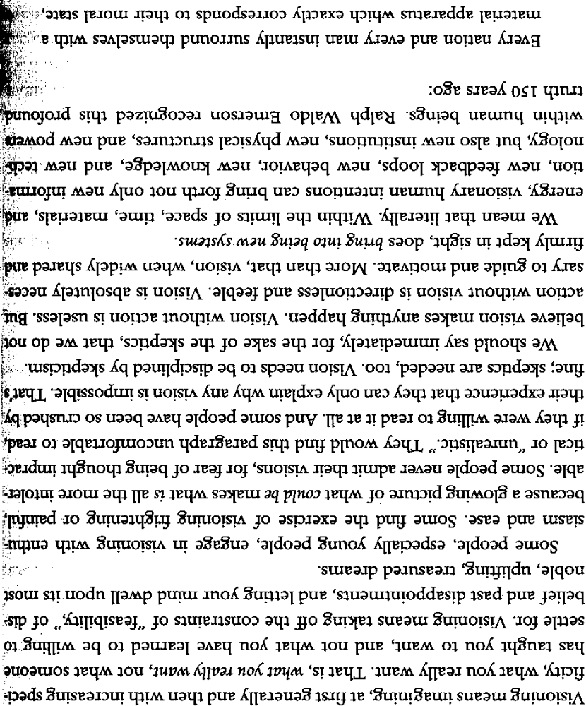
(continues on next page)
Perm: Visioning (2/2)

(continued)
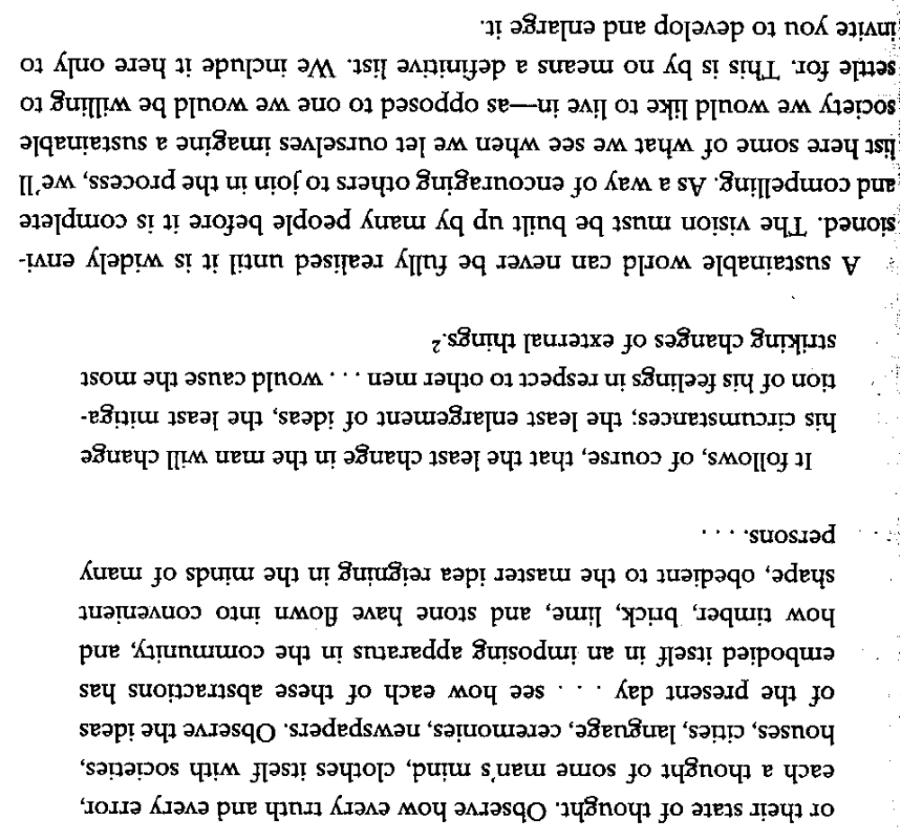
Humanism Good

A new humanism is necessary to create a peaceful and loving relationship with ourselves and existence
Aurelio Peccei, Italian scholar and industrialist, best known as the founder and first president of the Club of Rome, 1981; “Limits to Growth: The 30-year update”, p 272-273

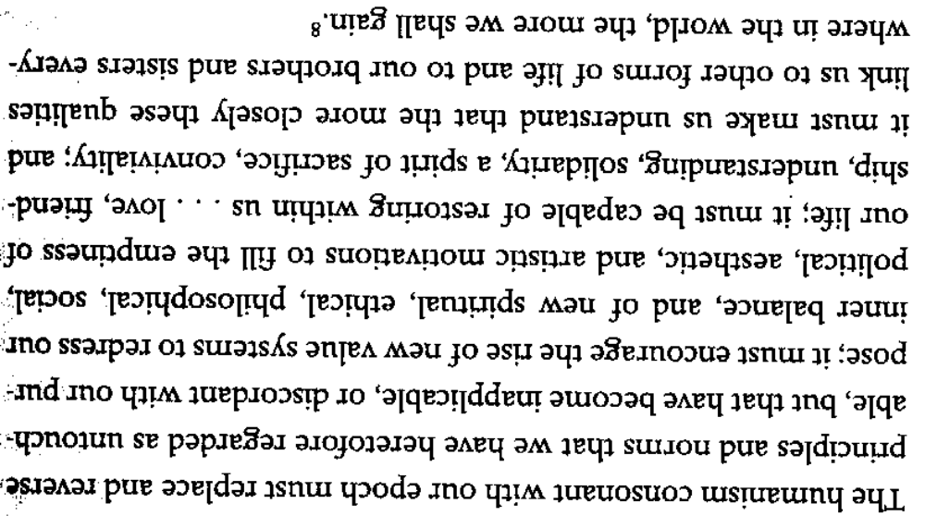

Heidegger→Nazism

Heidegger’s philosophy is directly correlative with the political views of a fascist state – his ‘resoluteness in the face of Nothing’ is at the core of Nazi ideology and justification for their violent suppression of argument
Julian Young, professor of philosophy at the University of Tasmania 1997 Heidegger, Philosophy, Nazism, p 80

